**Aim:** To obtain thesupport vectors for classification of the data points using support vector machine technique

**IDE:** Google Colab

**Theory:**

Support Vector Machine or SVM is one of the most popular Supervised Learning algorithms, which is used for Classification as well as Regression problems. However, primarily, it is used for Classification problems in Machine Learning.

The goal of the SVM algorithm is to create the best line or decision boundary that can segregate n-dimensional space into classes so that we can easily put the new data point in the correct category in the future. This best decision boundary is called a hyperplane.

SVM chooses the extreme points/vectors that help in creating the hyperplane. These extreme cases are called as support vectors, and hence algorithm is termed as Support Vector Machine. Consider the below diagram in which there are two different categories that are classified using a decision boundary or hyperplane:

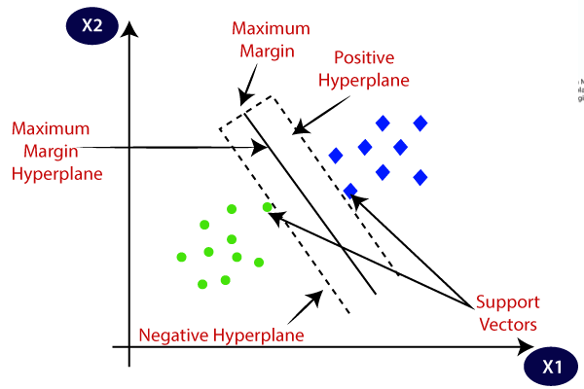

SVM algorithm can be used for **Face detection, image classification, text categorization,** etc.

## Types of SVM

**SVM can be of two types:**

* **Linear SVM:** Linear SVM is used for linearly separable data, which means if a dataset can be classified into two classes by using a single straight line, then such data is termed as linearly separable data, and classifier is used called as Linear SVM classifier.
* **Non-linear SVM:** Non-Linear SVM is used for non-linearly separated data, which means if a dataset cannot be classified by using a straight line, then such data is termed as non-linear data and classifier used is called as Non-linear SVM classifier.

## Hyperplane and Support Vectors in the SVM algorithm:

**Hyperplane:** There can be multiple lines/decision boundaries to segregate the classes in n-dimensional space, but we need to find out the best decision boundary that helps to classify the data points. This best boundary is known as the hyperplane of SVM.

The dimensions of the hyperplane depend on the features present in the dataset, which means if there are 2 features (as shown in image), then hyperplane will be a straight line. And if there are 3 features, then hyperplane will be a 2-dimension plane.

We always create a hyperplane that has a maximum margin, which means the maximum distance between the data points.

**Support Vectors:**

The data points or vectors that are the closest to the hyperplane and which affect the position of the hyperplane are termed as Support Vector. Since these vectors support the hyperplane, hence called a Support vector.

**Methodology:**

1. Load the basic libraries and packages
2. Load the dataset
3. Analyse the dataset
4. Normalize the data
5. Pre-process the data
6. Load Different Support Vector classifiers
7. Train the classifier
8. Predict over the test dataset
9. Obtain the confusion matrix for each of the classifier output

**Program (Code):**

To be attached with

**Results:**

To be attached with

1. Correlation graph between various features
2. Confusion matrix and classification report for (i) RBF, (ii) Linear, and (iii) Polynomial
3. Contour graph for different support vector classifiers

**Observation and Result Analysis:**

1. Nature of the dataset

________________________________________________________________________________________________________________________________________________________________________________________________________________________________________________________________________________________________

1. During Training Process

________________________________________________________________________________________________________________________________________________________________________________________________________________________________________________________________________________________________

1. After the training Process

________________________________________________________________________________________________________________________________________________________________________________________________________________________________________________________________________________________________

**Post Lab Exercise:**

1. What is the geometric intuition behind SVM?

________________________________________________________________________________________________________________________________________________________________________________________________________________________

## What do know about Hard Margin SVM and Soft Margin SVM?

## ______________________________________________________________________________________________________________________________________________________________________________________________________________________

1. What’s the “kernel trick” and how is it useful?

________________________________________________________________________________________________________________________________________________________________________________________________________________________

1. What is the role of C in SVM? How does it affect the bias/variance trade-off?

________________________________________________________________________________________________________________________________________________________________________________________________________________________

1. SVM being a large margin classifier, is it influenced by outliers?

________________________________________________________________________________________________________________________________________________________________________________________________________________________